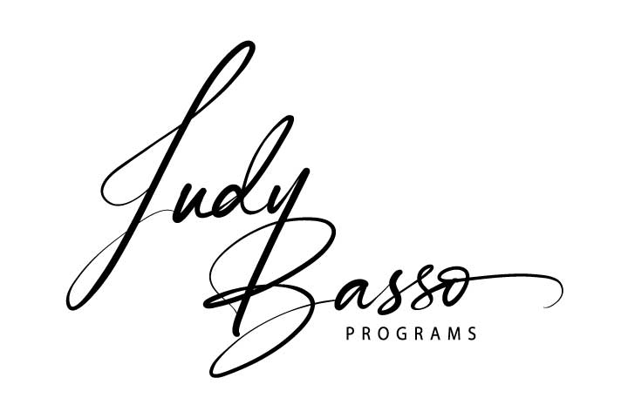
Business Vision Board Workshop –
With a Divine Twist
Outline

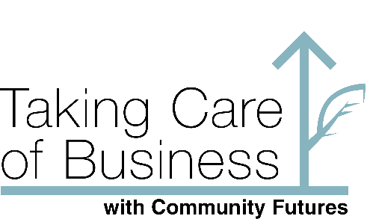

What does SUCCESS look like
For your business?
Learn How to make a powerful
Vision Board!

Learn how to make a powerful vision board - taking control of your future!
You have heard about vision boards, maybe even made them. A vision board is a way for you to get clarity on what you want in your future in any area of your life. Did you know that there is a special way to make them more effective and powerful? Vision Boards are a way to get very good clarity and be an attraction magnet for what you want in your life.
Vision boards are a hot topic now - because they work to help you have the life and things you want. But there is a way to make them be more effective, this is the way I teach it. Vision boards have become mainstream now, people have seen their results from making a vision board and are telling others. If you are going to take the time and effort to make a vision board, do it the right way so your time is well invested for you to see results. Many celebrities such as Oprah, Jim Carey, Katy Perry and more rave about how effective they are and how they helped to shape the successes they have had.

Outline of workshop session
A big part of creating an effective, creative, and beautiful vision board is getting into the right mindset. This five-hour workshop is meant to be held in a space where you can be quiet and uninterrupted for the duration of the whole workshop. There is a bit of prep work required before we start the workshop, just to get the right juices flowing. This is a unique way to make vision boards that work! It is done with a divine twist that will make it so easy for you to get clarity on the direction of your life, helping you to see how it is meant to unfold.
Part of your pre assignment is to get five or six old magazines. Just find any that catch your attention. It doesn't matter how old or new they are. This is part of the process of getting you in tune with your intuition and following your gut instinct on which to pick. We will be using these to make your vision boards, old school, literally cutting photos, words, phrases from the magazines and pasting onto a large display board.
After experimenting with digital versus hand made vision boards, I saw that there was a huge difference! The hand made ones were more organic and had much more energy making them more powerful. It also helps to keep you focussed on the task at hand, with out the distractions of going down the rabbit hole of the internet. The completed vision board is more in alignment to help magnetize the things that you really want to have, be or do in your business and personal life to come.
Participants are encouraged to have snacks and beverages ready for them to nibble that so that you can just keep the momentum going throughout the workshop. It would be a full, fun, and productive day creating a vision board to have the life you want.

Benefits
There is so much more than learning how to make a great vision board here. You will learn how to connect with your Inner Guidance, your soul, that is meant to steer you in the right path. This is a sharpening of trusting of your intuition then having the confidence in knowing you are truly heading into the life you were meant to have.
Working smarter, not harder to get what you want.
These are tools that you can tap into at anytime for anything throughout the rest of your life.

Handouts and resources
- Workshop Outline
- Why should you do a vision board?
- What you will get at the workshop
- Things That You Want to Be, Have or Do - a living changing document
- Checklist for prior to workshop
- Dream Scaping worksheet - will also get you thinking in ways that you may not have done before, or it is time to re-contemplate.
- Points to ponder
- 12 Steps to Creating an Effective Vision Board – the instructions on how actually construct the vision board.
- Tips on setting intentions
- At the end of the workshop, you will have completed a fabulous vision board
- Dream Tracker
- Resource list
Testimonials on effects of a Vision Board are available on my website: www.judybassoevents.ca

Workshop presenter
Judy Basso
Being an entrepreneur, owning her own very successful event planning business for 32 years has given Judy a wealth of knowledge and experience. She has gotten to the point in her career that she wants to share with others what she has learned. For the past ten years she has also been honing her skills on how to truly master making vision boards - that work! She states: “When you start to see your manifestations come to life, it is so exciting! Vision boards have helped me immeasurably in every area of my life personally and professionally. I feel it is my responsibility to share this knowledge so that I can help others with their dream life.”

